**Foraging, fear and behavioural reaction norms – a lesson from hummingbirds**

Katarzyna Wojczulanis-Jakubas1, Marcelo Araya-Salas2,3

1Department of Vertebrate Ecology and Zoology, University of Gdansk, Gdansk, Poland; biokwj@univ.gda.pl

2 Recinto de Golfito, Universidad de Costa Rica, Golfito, Costa Rica

3 Centro de Investigación en Neurociencias, Universidad de Costa Rica, San Pedro, San José, Costa Rica

**Abstract**

**…**

**Keywords**

risk allocation hypothesis, predator, prey, risk-avoidance, exploratory behaviour, arousal, repeatability

**Introduction**

It is now widely accepted that animal’s foraging strategy (i.e. resource exploitation) depends not only on the amount and distribution of available food resources (Morrison et al. 1990; Herborn et al. 2014), and animal motivation (both in the sense of marginal value theorem (Charnov 1976) and/or body condition (Bautista et al. 2001)) but also predation pressure (Lima and Bednekoff 1999). The intensity of a prey vigilance increases with the level of risk predation (proportion/probability of predator presence), affecting prey foraging efficiency. As the risk allocation hypothesis (RAH) imposes, a prey allocates time for foraging inversely proportionately to predation pressure (Lima and Bednekoff 1999; Verdolin 2006). In the light of such a time trade-off, a fixed foraging strategy is expected to evolve, an adaptive behavioural norm in a given food-resources – predation landscape (Krebs 1980). However, numerous studies have demonstrated a high inter-individual variation in the foraging strategy e.g. (Patrick et al. 2014; Camprasse et al. 2017; Moldoff and Westneat 2017).

Recently, animals behavioural plasticity has been pointed out as an important source of the inter-individual variation in performance of any strategy, including foraging decisions (Nussey et al. 2007; Bell et al. 2009; Dingemanse et al. 2009; Herborn et al. 2014; Alonzo 2015; Toscano et al. 2016). Increasing evidence suggests that individuals do differ in their average level of behaviour displayed across a range of contexts (Carere and Maestripieri 2013) and in their responsiveness to environmental variation (Nussey et al. 2007; Dingemanse et al. 2009). Within a species/population individuals usually represent a full continuum of a given behaviour display, with two polar opposite phenotypes (e.g. high and low exploratory) and various intermediate forms in between. Importantly, fitness advantages of the contrasting behavioural phenotypes differ in various context, sometimes dramatically. For example, highly exploratory behaviour may favour an individual in inter-individual competition but it may also be disadvantageous in conditions of high predation pressure (Dall et al. 2004; Réale et al. 2007; Smith and Blumstein 2008; Quinn et al. 2012).

How behavioural variability is maintained in the population if selection favours a single optimal response remains an open question. This is particularly intriguing in the context of the risk allocation hypothesis (Lima and Bednekoff 1999) where, in given conditions of food resources availability and predation risk, a fixed behaviour is expected to provide the highest fitness across all possible scenarios. This apparent paradox can be solved by examining the fitness consequences of various behavioural performance during foraging in a gradient of risk predation. Here, we investigated fitness consequences (expressed by foraging efficiency) in regard to three behavioural traits: exploration (number of feeders used during the foraging visit), risk-avoidance (latency to approach the feeder to forage), and arousal (amount of movement during the foraging visit) in the context of varying level of perceived predation risk, in wild ranging, long-billed hermit hummingbirds (LBH, *Phaethornis longirostris*).

Hummingbirds are known for their extreme metabolism, and high need for energy intake that makes them constantly motivated to forage (Suarez 1992). Hence, hummingbirds are expected to exhibit high foraging efficiency regardless of the risk levels. This is particularly significant for traplining foragers, which use flowers dispersed across the habitat in a route-like fashion, a more unpredictable resource that has favoured behavioural traits that improve foraging efficiency (Araya-Salas t al 2018). On the other hand, such a free foraging foraging entails a period of high vulnerability for hummingbirds, which is regularly exploited by a wide range of predators (Stiles 1978; Owen and Cokendolpher 2006; Lorenz 2007; Zenzal et al. 2013; Sazima 2015; Nyffeler et al. 2017). Thus, a trade-off between foraging and avoiding predation is expected to be particularly pronounced in hummingbirds. This obviously hinders *a priori* prediction for birds response to conditions of varying predation risk. We explored the trade-off between resource explotation efficiency and risk avoidance by examining individual variation on behavioral traits expected to affect foraging efficiency and their interplay with varying levels of risk. We expected that foraging efficiency will be positively correlated with exploratory behaviour. This is because exploratory individuals, often being more experienced as well as bolder in terms of risk-aversion (Carere and Maestripieri 2013) are likely to ignore somehow novel items, and onset foraging faster, compared to less exploratory individuals. For both risk-avoidance and arousal we expected a negative relationship with foraging efficiency. The two traits potentially increase time allocation for activities not related with foraging *per se*, so they are also likely to decrease foraging efficiency per unit of time. Finally, for each trait we measured its repeatability (Bell et al. 2009), thus evaluated them as personality traits (Dingemanse et al. 2009).

**Material and methods**

*Fieldwork.* We carried out the study at the area of one of LBH leks in La Selva Biological Station, Costa Rica (10 o23’ N, 84o10’ W) between May and June 2015. Birds were individually marked [foam tags of unique colour combinations, attached to bird back and breast with nontoxic eyelash glue, see Araya-Salas et al. 2018 for details] and habituated to use feeders. Of the XX birds marked at the study lek (XX territorials and XX floaters or females), 12 individuals regularly used feeders utilized in the present study (located at XX distance from the closest lek border) and so were tested in the experiment.

To quantify birds behaviour in various risk predation context, we applied a field experiment using a three one-flower feeders for the experimental set up. We arrange the feeders in a line, separated by ca 10 cm distance from each other. The experiment consisted of two phases – hereafter control and experimental. Both phases were performed at the same day, with the control being directly followed by the experimental phase. The experimental phase started at the moment when all the focal individuals have been recorded at the feeder for the control conditions, and lasted until all of them visited the feeder again in the experimental conditions. Since focal individuals visited feeders regularly, appearing at the feeders site on average XX times per hour, we were able to complete the two phases within ca XX hours. During both phases of the experiment the three feeders were filled up with ~ 30% sugar-water and birds were allowed to forage on the nectar spontaneously, while their behaviour at feeders site were recorded by human observer and a commercial camera (continuous recording mode). The only difference between the control and experimental phase were a threat model attached to feeders during the experimental phase. For the threat model, we used specimens of the bullet ant (*Paraponera clavata*; found dead in the forest). Although the ant is not a predator of hummingbirds (including LBH), the ant-bird encounter imposes potential danger for the bird in the form of being bitten. Indeed, an average birds response for the threat exposure was as expected (see results). We performed total of four complete control-experimental sessions within ca two weeks.

We first screened video recordings with VLC software (www.videolan.org), to locate and cut out video fragments with foraging visits of all focal birds. As a foraging visit we considered birds’ visit at the feeder area when it inserted the bill into a feeder at least once. For each visit (both at control and experimental phase) we established several crucial time-points (white and black circles on Fig. 1), with 0.1 seconds precision, using Cowlog software (Pastell 2016). Based on these time-points we calculated duration of events such as: latency to forage [the interval between appearance in the feeder area (usually hovering in front of the feeder) and the onset of foraging, i.e. distance a-b on Fig. 3]; foraging interval/s (e.g. distance b-c, Fig. 3; on average XX events); foraging break/s (e.g. distance c-d, Fig. 3; on average XX events); total foraging (distance b-e, Fig. 3) and total foraging visit (distance a-e, Fig. 3). For each visit we also noted which and how many times each of the three feeders were used by the focal bird.

To further analyse birds behaviour we calculated three functional behaviours, likely to be related to three personality traits: exploration, risk-avoidance and arousal (Réale et al. 2007). As a proxy for **exploratory behaviour** we utilized a **standardized number of feeders** - totalnumber of various feeders (i.e. 1-3 feeders) used during the foraging visit divided by the total foraging duration. As a proxy for **risk-avoidance** we used **latency to approach the feeder** – as defined above (latency to forage, distance a-b on Fig. 3). For both the parameters, we assumed that the higher the value, the stronger is the exhibited behaviour.

As **arousal** we considered a total amount/range of movements at the feeder recorded during the total foraging time (distance b-e on Fig. 3), standardized by the number of feeder changes. For that we first processed the video recordings using Tracker software (physlets.org/tracker), which allowed to establish Cartesian coordinates of a bird position for each video frame. Then, we calculated coefficient of variance of bird movements based on the formula: sqrt((xj - xi)2 + (yj - yi)2), where xi,j and yi,j are Cartesian coordinates of the bird position in a focal i and previous j video frame. Since the birds movements could be biased by exploratory behaviour, we standardized this coefficient dividing it by the number of feeder changes at given visit. We expected that the higher value of the coefficient, the higher arousal.

Finally, we calculated **foraging efficiency**, which was the ratio of total duration of foraging (sum of all feeding intervals) to the and duration of the foraging visit.

*Data analysis.*

All the analyses were performed in R environment (R Core Team 2017). We compared foraging efficiency between control and experimental conditions using linear mixed models (LMM; Zuur et al. 2009), with treatment as a fixed factor. To address the issue of pseudoreplication (related to multiple testing of the same individuals) we included bird’s identity as a random factor in the model. To test an effect of individual performance, we compared model with and without bird identity (*Chisq* test). For examining repeatability of individual’s behaviours we also applied modelling approach (Nakagawa and Schielzeth 2010) using *rptR* package (Stoffel et al. 2017). Then, we analysed foraging efficiency in regard to each behaviour separately, again using modelling approach (LMM), with treatment being a fixed factor and bird identity as a random factor.

**Results**

Foraging efficiency was strongly affected by the experimental treatment (LMM, estimate = -0.11, SE = 0.03, t = -3.91, df = 188.17, P < 0.001), in general being lower in experimental conditions (Fig 2A). There were also individual differences in foraging efficiency in response to the treatment (Chisq = 17.06, df = 1, P < 0.001), with some individuals being more efficient in control conditions while others exhibiting a reverse pattern; in one case foraging efficiency was similar in both control and experimental conditions (Fig. 2B).

**Repeatability** of behaviours was moderate and significant for exploration (R = 0.28, CI = [0.044, 0.475]; LRT: P < 0.001) and risk-avoidance (R = 0.269; CI = [0.064, 0.454], P < 0.001), and very low and insignificant for the arousal (R = 0.007, CI = [0, 0.09]; LRT: P ~ 1).

Overall, intensity of the **exploratory behaviour** (i.e. number of feeders used during the foraging visit) was related to foraging efficiency (LMM, estimate = 0.47, SE = 0.18, t = 2.53, df = 192.95, p = 0.01) though similar in the two treatment (LMM, estimate = 0.09, SE = 0.04, t = 2.12, df = 186.57, P < 0.04). Nevertheless, direction of the relationship between the number of feeders used and foraging efficiency was clearly condition-dependent (as indicated by the treatment x explorative behaviour interaction, LMM, t = -5.72 , df = 188.5, p < 0.001). It was positive in control conditions (LMM, estimate = 0.50, SE = 0.16, t = 3.18, df = 139.21, P = 0.002), and negative in threatening conditions (LMM, estimate = -0.93, SE = 0.21, t = -4.36, df = 49.87, P < 0.001 Fig. 3A).

Latency to approach a feeder (**risk-avoidance**) was affected by experimental treatment (LMM, estimate = -0.13, SE = 0.04, t = -3.16, df = 191.33, P = 0.002; Fig. 5B). Overall, and independently on conditions, foraging efficiency decreased with the duration of the latency (LMM, estimate = -0.02, SE = 0.01, t = -2.19 , df = 191.99, P = 0.03; interaction of latency and treatment: estimate = 0.02, SE = 0.01, t = 1.53, df = 191.99, P = 0.13; Fig. 3B).

The range of birds movements (**arousal**) was positively related to foraging efficiency (LMM, estimate = 0.04, SE = 0.01, t = 3.85, df = 188.55, P < 0.001), and overall higher in the threatening conditions (LMM, estimate = -0.33, SE = 0.05, t = -6.13, df = 188.71, P < 0.001). The relationship between the foraging efficiency and arousal was also stronger in the experimental conditions (as indicated by the treatment x exploratory behaviour interaction, LMM, t = 5.23, df = 188.36, p < 0.001; Fig. 3C).

**Discussion**

As we expected in the light of the risk allocation hypothesis (Lima and Bednekoff 1999) foraging efficiency of the LBH decreased in response to threatening conditions. However, behavioural performance of individuals in regard to exploration, risk-avoidance and arousal additionally affected the foraging efficiency, interestingly in condition-dependent manner. These results demonstrate that a range instead of a single, fixed strategy should be considered, when modelling the time allocation into foraging in the context of predation pressure. The results also highlight the importance of behavioural variability in shaping evolution of foraging strategy.

Despite not being a specific target of any predator, hummingbirds may be opportunistically hunted by a wide range of predators (e.g. Owen and Cokendolpher 2006; Lorenz 2007; Zenzal et al. 2013; Sazima 2015; Nyffeler et al. 2017). That imposes a considerable predation risk and favours evolution of risk-avoidance behaviour. Indeed, we found that experimental exposure of an ant, that potentially represents just a threat of being bitten (but not eaten), was enough for LBHs to exhibit higher risk-avoidance (longer latency to approach the feeder) and lower movement activity compared to the control conditions. Importantly, despite of the threat birds did forage, although with a lower efficiency. This places LBHs, and potentially trap-lining if not all hummingbird species, in the group of animals representing so call paradox of risk-allocation hypothesis. In conditions of a frequent predator presence, prey might need to forage actively even though predators are present (Lima and Bednekoff 1999; Ferrari et al. 2009). It is worth to note that, one of assumptions of the RAH is ‘living on the edge’ in terms of meeting energy demands. This assumption seems to be rarely met in most of animal species used to test the hypothesis so far (Ferrari et al. 2009) but hummingbirds, given their extreme metabolism rate, could be a rare example when the assumption is actually true.

The changes in LBHs behaviour in response to a threat, longer latency and lower arousal, are likely to be adaptive. A longer time spent at the foraging site before the feeding onset may allow an individual to thoroughly evaluate the risk-level and so make adequate foraging decision. If a threat is no mortal, as it was probably the case in the present study, the individual initiates foraging despite being threaten, otherwise it might search another food resource or postpone foraging event. Adaptiveness of decreased activity of a prey in the condition of high-risk predation would related to lower chances of being spotted and so hunted by a predator. Indeed, decreased movement activity is expected in the light of the RAH (Lima and Bednekoff 1999) with some evidence supporting this prediction (e.g. Sih and McCarthy 2002 but see other examples reviewed in Ferrari et al. 2009). This prediction may not be fully applicable for the LBHs in the present study, as here the prey was in a full exposure to the threat (i.e. “already spotted by a predator”). An alternative explanation could be a cognitive overload associated with the need to evaluate the risk situation, which could affect locomotor activity. The exploratory behaviour was similar regardless of the circumstances, which may be surprising if to assume that less exploratory behaviour would be expected in threatening conditions for the same reasons as for the arousal. This lack of differences in the exploratory behaviour between control and experimental conditions could be explained in the context of birds personality (see below).

Each of the examined behaviour affected foraging efficiency, and in case of the exploratory behaviour the effect was dependent on the circumstances. In control conditions individuals exhibiting more exploratory behaviour had also overall higher food intake during the foraging visit. Interestingly reversed pattern was observed for the experimental conditions. As simple reason of this pattern is that each time an individual stopped feeding to change feeder it had longer time intervals, probably associated with the need to analyse “de novo” the risk situation. If to assume that exploratory behaviour is a personality trait (see below), thus behaviour exhibited by an individual which is consistent over the time and context (XXXX), and the trait has apparently different fitness consequences in regard to predation, the predation pressure is likely to shape frequency of behavioural phenotypes. Although we are not able to test this prediction currently, to encourage future studies, we highlight the role of predators is evolution of personality (XXX).

Risk avoidance negatively affected foraging efficiency, meaning that individuals exhibiting high risk-aversion might jeopardize their survival in terms of energy intake while individuals with low-risk aversion, although benefiting from high foraging efficiency, would be more likely to be predated. The fitness consequences of this trade-off related to the behaviour are obviously condition dependent. If the risk-avoidance, as measured in the present study (i.e. latency to initiate foraging), was related to birds personality (see below), the relationship between that and foraging efficiency would contribute in the selection of given behavioural phenotype in given predation risk level. Consistently, changing and/or unpredictable level of risk predation would maintain variability in this behavioural phenotype.

To maximize fitness, hummingbirds should adaptively allocate both the exploratory and risk-avoidance behaviour. Given results of our study, we could try to predict differences in foraging strategy between two groups of hummingbirds of distinct foraging strategy, trappliners that …. and territorials that ….. (XXX). Obviously, making these differences precise we would too much speculate. However, indeed numerous differences in foraging strategy of trapliners and territorlas could be listed (XXX), and our study would simply highlight the importance of predator pressure in shaping these differences.

An increasing foraging efficiency along with an increase of arousal maybe at first glance counterintuitive, time allocated to movements potentially limits the time for foraging. However, arousal was not a repeatable trait, thus an animal arousal may be an outcome of its nutritional state, and more active individuals could be more effective during the foraging owing to their good body condition.

Both exploratory and risk-avoidance behaviour were quite repeatable for individuals suggesting that these two behaviours are potentially related to birds personality (XXXX). Three different groups in foraging efficiency in response to experimental threatening (increased, decreased and unchanged foraging efficiency, Fig. XX) additionally suggest that individuals respond to given conditions in different way, possibly depending on their personality. Thus, in a constantly changing environment, varying fitness consequences of given behavioural phenotype would maintain variation in animals personality. If indeed the exploratory and risk-avoidance behaviour are at least partially heritable personality traits, one could use them to model an evolutionary scenario for given behavioural phenotypes in various conditions of predation pressure. We are currently not able to perform any analysis of that kind given the low number of tested individuals (n = 12) but we point out hummingbirds as potential animal model species in the studies of animals personality.

**Acknowledgments**

**References**

Alonzo SH (2015) Integrating the how and why of within-individual and among-individual variation and plasticity in behavior. Curr Opin Behav Sci 6:69–75

Araya-Salas M, Gonzalez-Gomez P, Wojczulanis-Jakubas K, et al (2018) Spatial memory is as important as weapon and body size for territorial ownership in a lekking hummingbird. Sci Rep 8:. doi: 10.1038/s41598-018-20441-x

Bautista LM, Tinbergen J, Kacelnik A (2001) To walk or to fly? How birds choose among foraging modes. Proc Natl Acad Sci U S A 98:1089–1094. doi: 10.1073/pnas.98.3.1089

Bell AM, Hankison SJ, Laskowski KL (2009) The repeatability of behaviour: a meta-analysis. Anim Behav 77:771–783. doi: 10.1016/j.anbehav.2008.12.022

Camprasse ECM, Cherel Y, Bustamante P, et al (2017) Intra-and inter-individual variation in the foraging ecology of a generalist subantarctic seabird, the gentoo penguin. Mar Ecol Prog Ser 578:227–242. doi: 10.3354/meps12151

Carere C, Maestripieri D (2013) No Animal Personalities. The University of Chicago Press

Charnov EL (1976) Optimal foraging, the Marginal Value Theorem. Theor Popul Biol 9:739–752

Dall SRX, Houston AI, McNamara JM (2004) The behavioural ecology of personality: consistent individual differences from an adaptive perspective. Ecol Lett 7:734–739. doi: 10.1111/j.1461-0248.2004.00618.x

Dingemanse NJ, Kazem AJN, Reale D, Wright J (2009) Behavioural reaction norms: animal personality meets individual plasticity. Trends Ecol Evol 25:81–89. doi: 10.1016/j.tree.2009.07.013

Ferrari MCO, Sih A, Chivers DP (2009) The paradox of risk allocation: a review and prospectus. Anim Behav 78:579–585. doi: 10.1016/j.anbehav.2009.05.034

Herborn KA, Heidinger BJ, Alexander L, Arnold KE (2014) Personality predicts behavioral flexibility in a fluctuating, natural environment. Behav Ecol 25:1374–1379. doi: 10.1093/beheco/aru131

Krebs JR (1980) Optimal foraging, predation risk and territory defence. Ardea 68:83–90. doi: 10.5253/arde.v68.p83

Lima SL, Bednekoff PA (1999) Temporal variation in danger drives antipredator behavior: the predation risk allocation hypothesis. Am Nat 153:649–659. doi: 10.1086/303202

Lorenz S (2007) Carolina mantind (Stagmomantis carolica) captures and feeds on a broad-tailed hummingbird (Selasphorus platycercus). Bull Texas Ornithol Soc 40:1–40

Moldoff DE, Westneat DF (2017) Foraging sparrows exhibit individual differences but not a syndrome when responding to multiple kinds of novelty. Behav Ecol 28:732–743. doi: 10.1093/beheco/arx014

Morrison MM, Raplph CJ, Verner J, Jehl JRJ (1990) Avian Foraging: theory, methodology and applications

Nakagawa S, Schielzeth H (2010) Repeatability for Gaussian and non-Gaussian data: a practical guide for biologists. Biol Rev 85:935–956. doi: 10.1111/j.1469-185X.2010.00141.x

Nussey DH, Wilson AJ, Brommer JE (2007) The evolutionary ecology of individual phenotypic plasticity in wild populations. J Evol Biol 20:831–844. doi: 10.1111/j.1420-9101.2007.01300.x

Nyffeler M, Maxwell MR, Remsen J V. (2017) Bird predation by praying mantises: a global perspective. Wilson J Ornithol 129:331–344. doi: 10.1676/16-100.1

Owen JL, Cokendolpher JC (2006) Tailless Whipscorpion (Phrynus longipes) feeds on Antillean crested hummingbird (Orthorhyncus cristatus). Wilson J Ornithol 118:422–423. doi: 10.1676/05-062.1

Pastell M (2016) CowLog – cross-platform application for coding behaviours from video. J. open Res. Softw. 25:1–4

Patrick SC, Bearhop S, Grémillet D, et al (2014) Individual differences in searching behaviour and spatial foraging consistency in a central place marine predator. Oikos 123:33–40. doi: 10.1111/j.1600-0706.2013.00406.x

Quinn JL, Cole EF, Bates J, et al (2012) Personality predicts individual responsiveness to the risks of starvation and predation. Proc R Soc B 279:1919–1926. doi: 10.1098/rspb.2011.2227

R Core Team (2017) R: A language and environment for statistical computing. R

Réale D, Reader SM, Sol D, et al (2007) Integrating animal temperament within ecology and evolution. Biol Rev 82:291–318. doi: 10.1111/j.1469-185X.2007.00010.x

Sazima I (2015) Lightning predator: the ferruginous pygmy owl snatches flower-visiting hummingbirds in southwestern Brazil. Rev Bras Ornitol 23:12–14

Sih A, McCarthy TM (2002) Prey responses to pulses of risk and safety: Testing the risk allocation hypothesis. Anim Behav 63:437–443. doi: 10.1006/anbe.2001.1921

Smith BR, Blumstein DT (2008) Fitness consequences of personality: a meta-analysis. Behav Ecol. doi: 10.1093/beheco/arm144

Stoffel MA, Nakagawa S, Schielzeth H (2017) rptR: repeatability estimation and variance decomposition by generalized linear mixed-effects models. Methods Ecol Evol 8:1639–1644. doi: 10.1111/2041-210X.12797

Suarez RK (1992) Hummingbird flight: Sustaining the highest mass-specific metabolic rates among vertebrates. Experientia 48:565–570. doi: 10.1007/BF01920240

Toscano BJ, Gownaris NJ, Heerhartz SM (2016) Personality , foraging behavior and specialization: integrating behavioral and food web ecology at the individual level. Oecologia. doi: 10.1007/s00442-016-3648-8

Verdolin JL (2006) Meta-analysis of foraging and predation risk trade-offs in terrestrial systems. Behav Ecol Sociobiol 60:457–464. doi: 10.1007/s00265-006-0172-6

Zenzal TJ, Fish AC, Jones TM, et al (2013) Observations of Predation and Anti-Predator Behavior of Rubythroated Hummingbirds During Migratory Stopover. Southeast Nat 12:N21–N25. doi: 10.1656/058.012.0416

Zuur AF, Leno EN, Walker NJ, et al (2009) Mixed Effects Models and Extensions in Ecology with R

**Figure 1.** Components of the foraging visit.

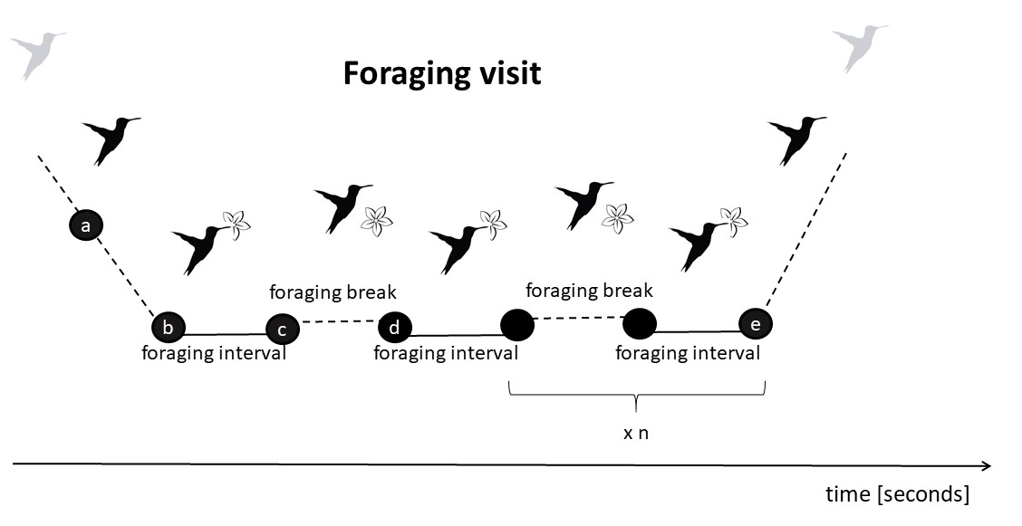

**Figure 2.** Average foraging efficiency of each focal individual in the context of low (control) and high (experimental) levels of perceived risk of predation.

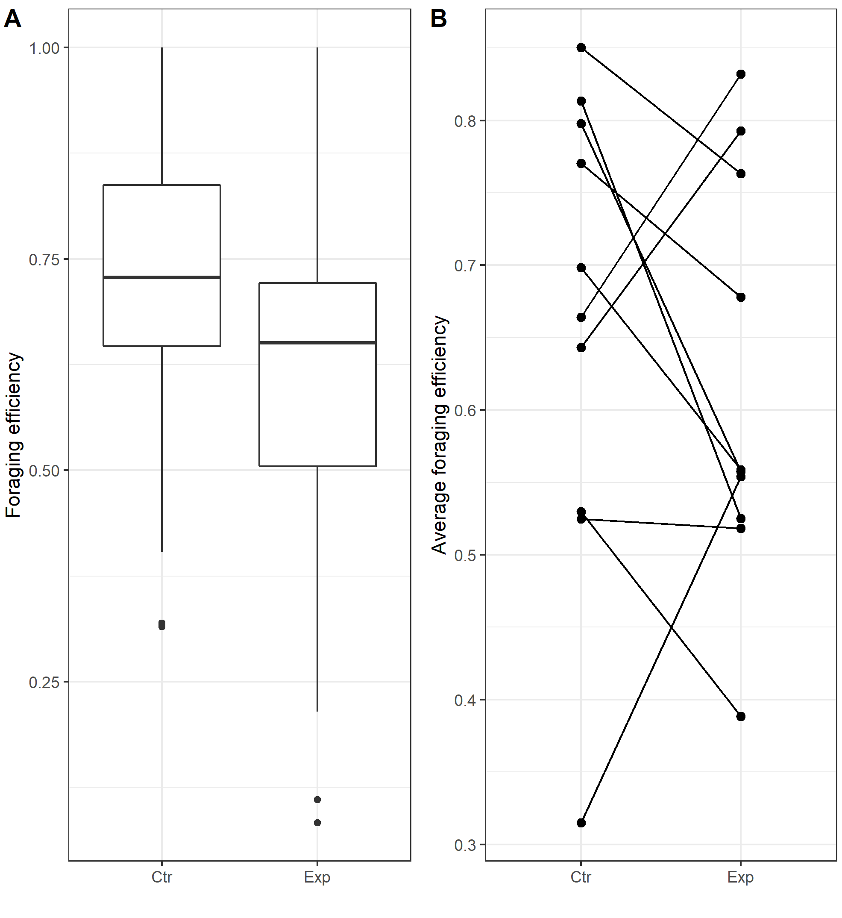

**Figure 3.** Foraging efficiency of long billed hermits in regard to their behavioural performance in the context of low (control - Ctr) and high (experimental - Exp) levels of perceived risk of predation.

